Bansilal Ramnath Agarwal Charitable Trust’s

**Vishwakarma Institute Of Information Technology, Pune**

**A PROJECT REPORT**

**ON**

**“MOVIE REVIEW SYSTEM”**

SUBJECT : IT Workshop (JAVA)

Submitted by

Shreyas Asutkar Roll No. 224005 Gr No. 21810004

Nikit Gokhe Roll No. 224024 Gr No. 21810522

Date:

21/05/2020

**Table of Contents:**

* ABSTRACT
* INTRODUCTION
* PROJECT OVERVIEW
* PROJECT RESULT AND OUTPUTS
* CONCLUSION
* **ABSTRACT:**

We plan and build up a simple java programming language project which simply helps user to find his/her movie of interest based on given movie review and rating by another person. This generated review will be a simple English statement and will help user to take a correct decision while selecting any movie. Also, the system is providing a fast searching feature. Our system is going to provide annotating search results. This will be achieved by Alignment algorithm. With the help of this, user will be able to search his/her favorite movie with in no time It is a film rating and survey rundown framework in a versatile domain. The Online Movie Review System provides reviews and ratings to any movie and suggest movie to the user. The motion picture rating data depends on the assumption characterization result. The consolidated portrayals of film audits are produced from the component-based synopsis. We propose a simple approach in which user can review and rate the movie according to him without any restrictions, also can see reviews of another user.

* **INTRODUCTION:**

People’s opinion has become one of the extremely important sources for various services in ever-growing popular social networks. In particular, online opinions have turned into a kind of virtual currency for businesses looking to market their products, identify new opportunities, and manage their reputations. In general, recommender systems are defined as the supporting systems which help users to find information, products, or services (such as books, movies, music, digital products, websites, and TV programs) by aggregating and analyzing suggestions from other users, which means reviews from various authorities, and user attributes. After viewing such reviews they take their decisions. So, such reviews must be correct and proper.

Generally, the reviews are generated in graphical format that is in star ratings. Users just have to see the ratings which are generated by analyzing the ratings given by other users to that product and have to take his/her decisions. Such ratings are easily understandable by any user. But they don’t give clear idea of how the product is. They are helpful only in the scenario where if any product is excellent or very poor. The scenario where product is average, star ratings prove bit confuse for any user. They don’t get clear views of what the other users think of that product. If the reviews are in simple English statement it would be easy for any user to understand the feelings of the other users too, about the product. Also star ratings will be there for his/her help.

So, the review about any product will give clear idea to any user so that he can easily take his/her decisions in such confusing scenario too. Our system is a movie review system which will generate reviews related to the movies which are released. Unlike other systems, we are going to generate a common review by analyzing only the comments of the people (no heavy feedback). This will reduce the overhead of any user who is commenting on any movie and will make the system more userfriendly. So, the system will generate better review which will be a simple English statement.

* **PROJECT OVERVIEW:**

**Tools Used:**

~Operating System : Windows10  
~Front End : Java, Jsp

* ~Back End : Database  
  ~Scripts : JavaScript.  
  ~Database : Mysql  
  ~Database Connectivity : JDBC.

**Application Contents:**

~Login page(User id/Password)

~Search Option

~Add review/Rate Option

~See Reviews

~Logout

* **PROJECT RESULT AND OUTPUT:**

1. Login Window:

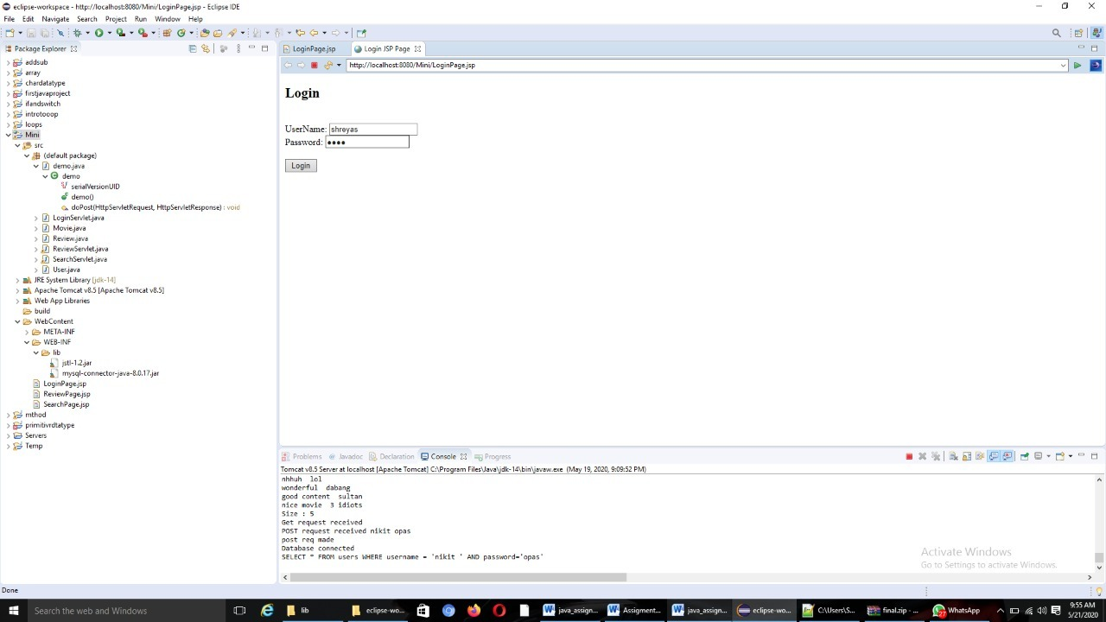

1. Search window :

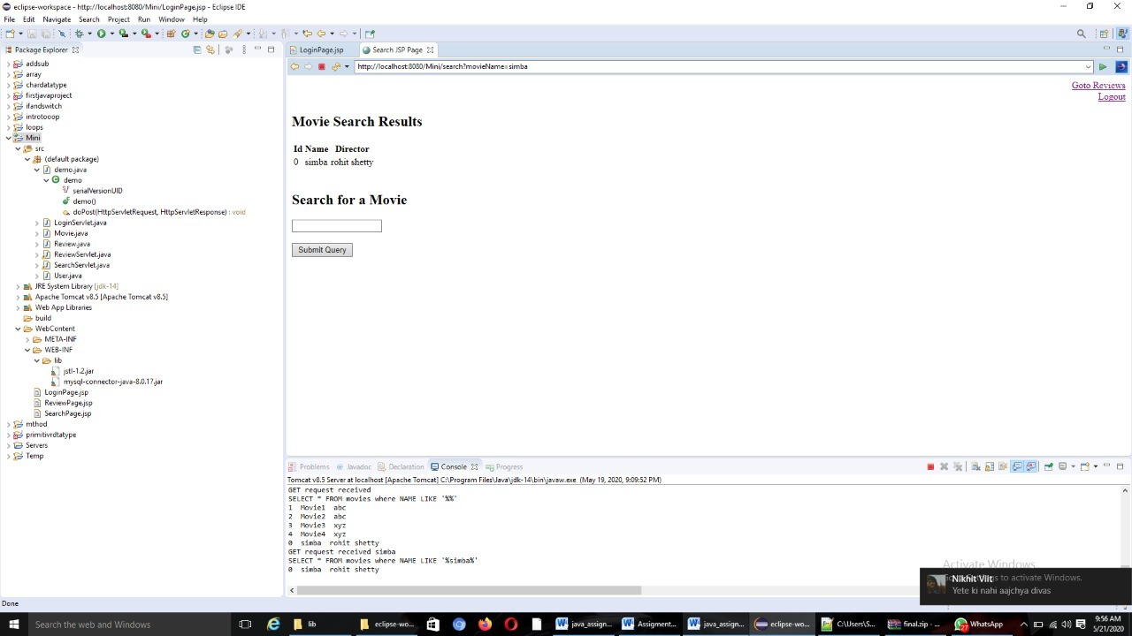

1. Add Review:

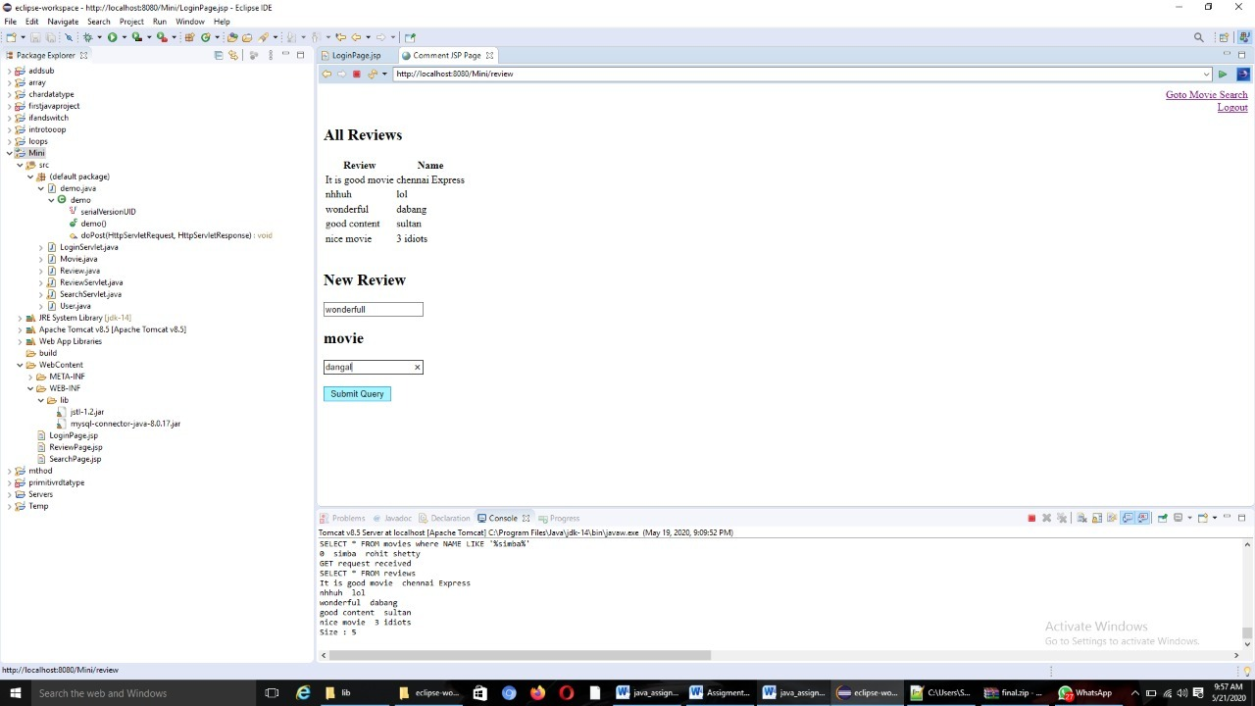

1. See Reviews and logout:

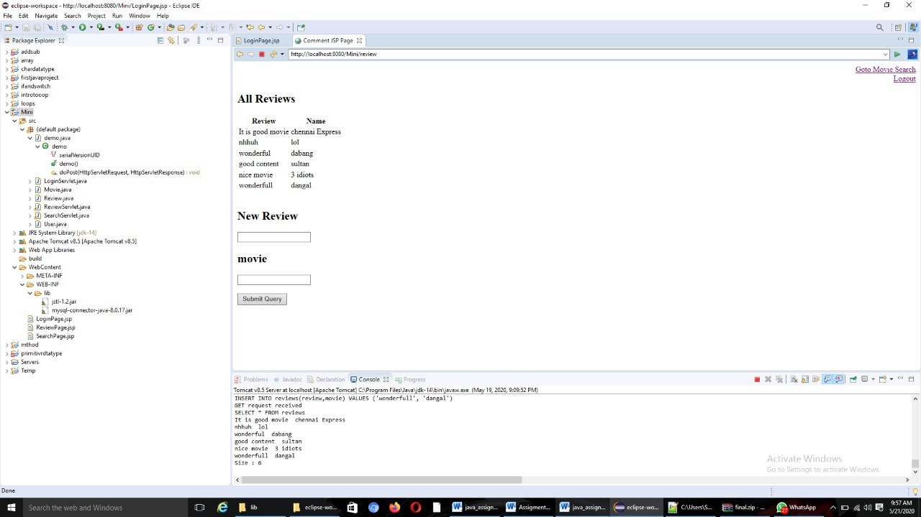

* **CONCLUSION:**

In this paper, we design and implement a movie-rating and review-summarization system. Sentiment classification is applied to the movie reviews, and rating information is based on sentiment-classification results. We plan and build up a simple java programming language project which simply helps user to find his/her movie of interest based on given movie review and rating by another person. This generated review will be a simple English statement and will help user to take a correct decision while selecting any movie. Also, the system is providing a fast searching feature. Our system is going to provide annotating search results. This will be achieved by Alignment algorithm. With the help of this, user will be able to search his/her favorite movie with in no time